**Problem Solving**

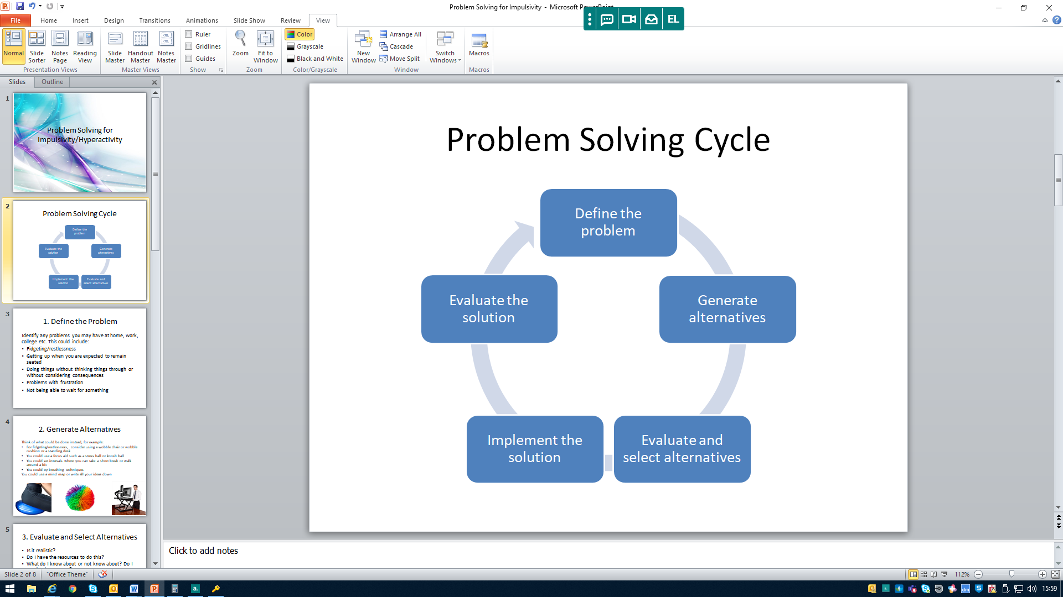

1. Define the problem:

___________________________________________________________________________________________________________________________________________________________________________________________________________________________________________________________________________________________________________________________________________________________________________________________________________

1. Generate alternatives

Alternatives

1. Evaluate and Select Alternatives

|  |  |  |
| --- | --- | --- |
| Top 5 | Top 3 | Best one |
| 1.  2.  3.  4.  5. | 1.  2.  3. | 1. |

(Remember it’s ok if you use more than one)

1. Implement the solution
2. Evaluate

How did it go?

Did it work?

Did any other problems crop up? If yes what were they?